Manila Water Company
FUNCTIONAL SPECIFICATION – FORM
DID_R2R_290, DID_R2R_291, DID_R2R_292
Form printout of RFP
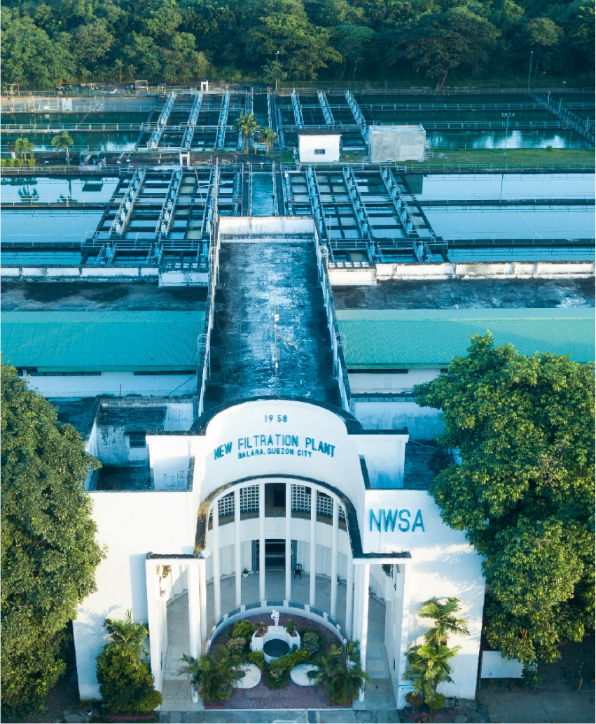

Customer NameDocument Title





Contents
1.1 Document Log 4
1.2 Integration, Document Reference 4
2 Functional Description 4
2.1 Assumptions 4
2.2 Processing Type 4
2.3 Output Type 5
2.4 Functional Design 5
2.5 Security / Authorization Requirements 7
2.5.1 Definition 7
2.5.2 Defined Fields 8
2.5.3 Procedure 8
2.6 Process Flow Diagram 8
2.7 SAP Transaction 8
2.8 Form Layout 8
2.9 Printer Requirements 11
2.10 Legal Requirements 11
2.11 Form Fields 11
2.11.1 Sub Heading 11
2.11.2 Totaling 11
2.11.3 Sorting 11
2.11.4 Page Breaks 11
2.11.5 Stationery 11
2.11.6 Logo(s) 11
2.12 Bar Coding Requirements 11
2.13 Email Requirements 11
2.14 Existing Sample Forms 11
3 Assumptions in Functional Design 11
4 Open Issues in Functional Design 11
5 Business Test Conditions 12
6 Related Documentation 12
Document Organization
This section provides details about this document, previous version(s) of this document and the document(s) referred.

Document Log
Following table mentions the version changes and the processer(s):
Version | Status | Date | Version Created by (Name/E-Mail/Company) | Role | Comments
0.1 | Draft | June 30, 2025 | Kenneth Chan | Author | Initial Draft
1.0 | Ready for Review | July 4, 2025 | Kenneth Chan | Author | Initial Draft
2.0 | ​​Ready for Review​ | ​​ July 7, 2025 | Roopali Sharma  roopali.sharma02@sap.com  Mohanrangan  Mohanrangan.rangarajan@sap.com | ​​Reviewer​ | Technical Review

Integration, Document Reference

S. No. | Referred Document Name | Referred Document Version | Referred Document URL (Optional)
DID_S2P_024 | Flexible Workflow for PR_SES_RFP
DID_R2R_372 | Workflow for Financial Posting

The documents listed here are explicitly not part of this Functional Specification. They are not automatically accepted together with this Specification but may be subject to a separate customer/SAP acceptance.

Functional Description
MWC is required to comply with regulatory requirements from Concession body. One of these requirements is to have physical printout of the approval of all RFP (Request for Payment).

Assumptions
Corresponding RFP FI documents were properly posted via System Workflow and usage of correct document types are necessary for RFP form to work.

Processing Type
Real Time

The forms will be triggered directly via a custom transaction code (T-code), where users initiate the print. Upon execution, the system will retrieve the required data in real-time based on input parameters given, type of RFP and according to the custom design, generate the output in PDF format for printing.

Output Type

Functional Design
RFP Form Print Program will manage mainly 4 types of RFP Forms in MWC:
- RFP for PO based Invoice/Documents
- Non-PO based Invoice/Documents (Direct FI)
- Vendor Downpayment Requests

Custom Adobe Forms for Request for Payment (RFP)
Trigger: Via Custom Transaction Code
Form Output: Adobe Form – Portrait
Both Adobe Forms will be integrated with their respective custom print programs to dynamically fetch data from standard SAP tables. The final output will be generated in PDF format and presented directly through the custom T-code for printing and emailing.
- 1. Business Requirement Summary
The client requires customized Adobe Forms for FI documents triggered via a custom transaction code. Each form should be rendered in a portrait layout
- 2. Input Parameters (from App)
The custom transaction code includes a structured input screen where users provide key document selection parameters and specify the required output type using clearly defined tabs and options.
Document Selection Parameters
- Document Selection Parameters
Based on the document type selected on the first screen, this screen collects the necessary filtering criteria.

Table/  Structure Name | Field Name | Format | Default Value | Table Value/  Checkbox/  Radio Button/  Radio Button Group | Select Option or Parameter | Mandatory or Optional | Field Labels
BKPF | BUKRS | CHAR |  | Table Value | Parameter | Mandatory | Company Code
BKPF | BELNR | CHAR |  | Table Value | Parameter | Optional | Document Number
BKPF | XBLNR | CHAR |  | Table Value | Parameter | Optional | Reference Number
RBKP | RE_BELNR | CHAR |  | Table Value | Parameter | Optional | MM Invoice Number
BSEG | LIFNR | CHAR |  | Table Value | Parameter | Optional | Supplier
BKPF | BUDAT | Date |  | Table Value | Parameter | Optional | Posting Date
BKPF | GJANR | Year |  |  | Single Parameter | Mandatory | Fiscal Year
 |  |  |  | Radio Button | Selection Option:  - PO Based Supplier Transaction  - Non-PO Based FI Supplier Transaction  - Downpayment Requests | Mandatory | RFP Type
 |  |  |  | Radio Button | Selection Option:  - Online  - Background | Mandatory
 |  |  |  | Path | Parameter | Optional

Hide selection parameter for MM Invoice when radio button select is not PO Based Supplier Transactions

- 3. Custom Table
RFP Type to Document Type Mapping
Field Label (Columns) | Primary Key | Table/  Structure Name | Field Name
RFP Type | Primary Key
Document Type |  | BKPF | BLART

Field Values:
- RFP Type:
  - PO Based Supplier Transaction
  - Non-PO Based FI Supplier Transaction
  - Downpayment Requests

Logic Radio Button for RFP Type
- PO Based Supplier Transaction
- Go to BKPF and get all the documents based on the selection parameters (BUKRS, BELNR, XBLNR, RE_BELNR, BUDAT, GJANR) AND Document Types from Custom RFP Table for PO Based Supplier Transaction
- Using the reference key (BKPF-AWKEY = RBKP-RE_BELNR+GJANR) where BKPF-AWTYP = “RMRP” get and join the corresponding MM Invoice from RBKP based on the selection MM Invoice (RBKP-RE_BELNR) and Fiscal Year (GJANR)
- From the list of documents, retain only those with line item with Vendor from selection parameters (BSEG-LIFNR).
- Get workflow details from DID_S2P_024 Flexible Workflow for PR_SES_RFP

- Non-PO Based FI Supplier Transaction
- Go to BKPF and get all the documents based on the selection parameters (BUKRS, BELNR, XBLNR, RE_BELNR, BUDAT, GJANR) AND Document Types from Custom RFP Table for Non-PO Based FI Supplier Transaction.
- From the list of documents, retain only those with line item with Vendor from selection parameters (BSEG-LIFNR).
- Get workflow details from DID_R2R_372 Workflow for Financial Posting

- Downpayment Request
- Go to BKPF and get all the documents based on the selection parameters (BUKRS, BELNR, XBLNR, RE_BELNR, BUDAT, GJANR) AND Document Types from Custom RFP Table for Non-PO Based FI Supplier Transaction.
- Get list of special GL indicator(UMSKZ) configured as noted item(T074U-KOART = ‘K’ AND UMSKS = ‘A’ AND MERKP = ‘X’
- From the list of documents, retain only those with line item with Vendor from selection parameters (BSEG-LIFNR) and applicable special GL indicator from step 2 (BSEG-UMSKZ)
- Get workflow details from BTP Downpayment Request Workflow

Using the documents extracted, get the corresponding workflow details and prepare the forms based on the form format and form field mapping.
Logic Radio Button for Processing Type
- Online
- Hide the path input parameter
- Based on selected documents from RFP Type logic, print the forms in the next screen showing all documents.
- Background
- Show the path input parameter
- Based on selected documents from RFP Type logic, save each document form per file in the path with the file name Company Code + Document Number + Fiscal Year.pdf

Security / Authorization Requirements

Definition
MWC is required to comply with regulatory requirements from Concession body. One of these requirements is to have physical printout of the approval of all RFP(Request for Payment).

Defined Fields

Procedure

Process Flow Diagram

SAP Transaction
Custom Transaction to be developed

Form Layout

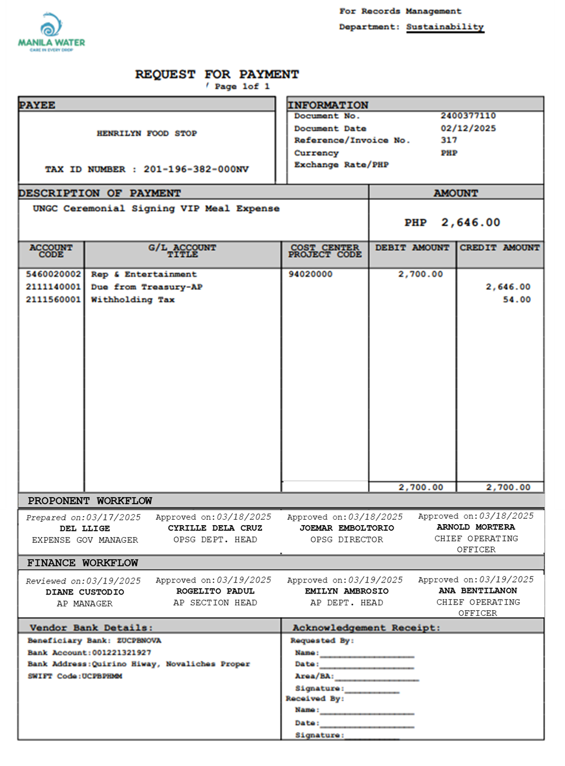

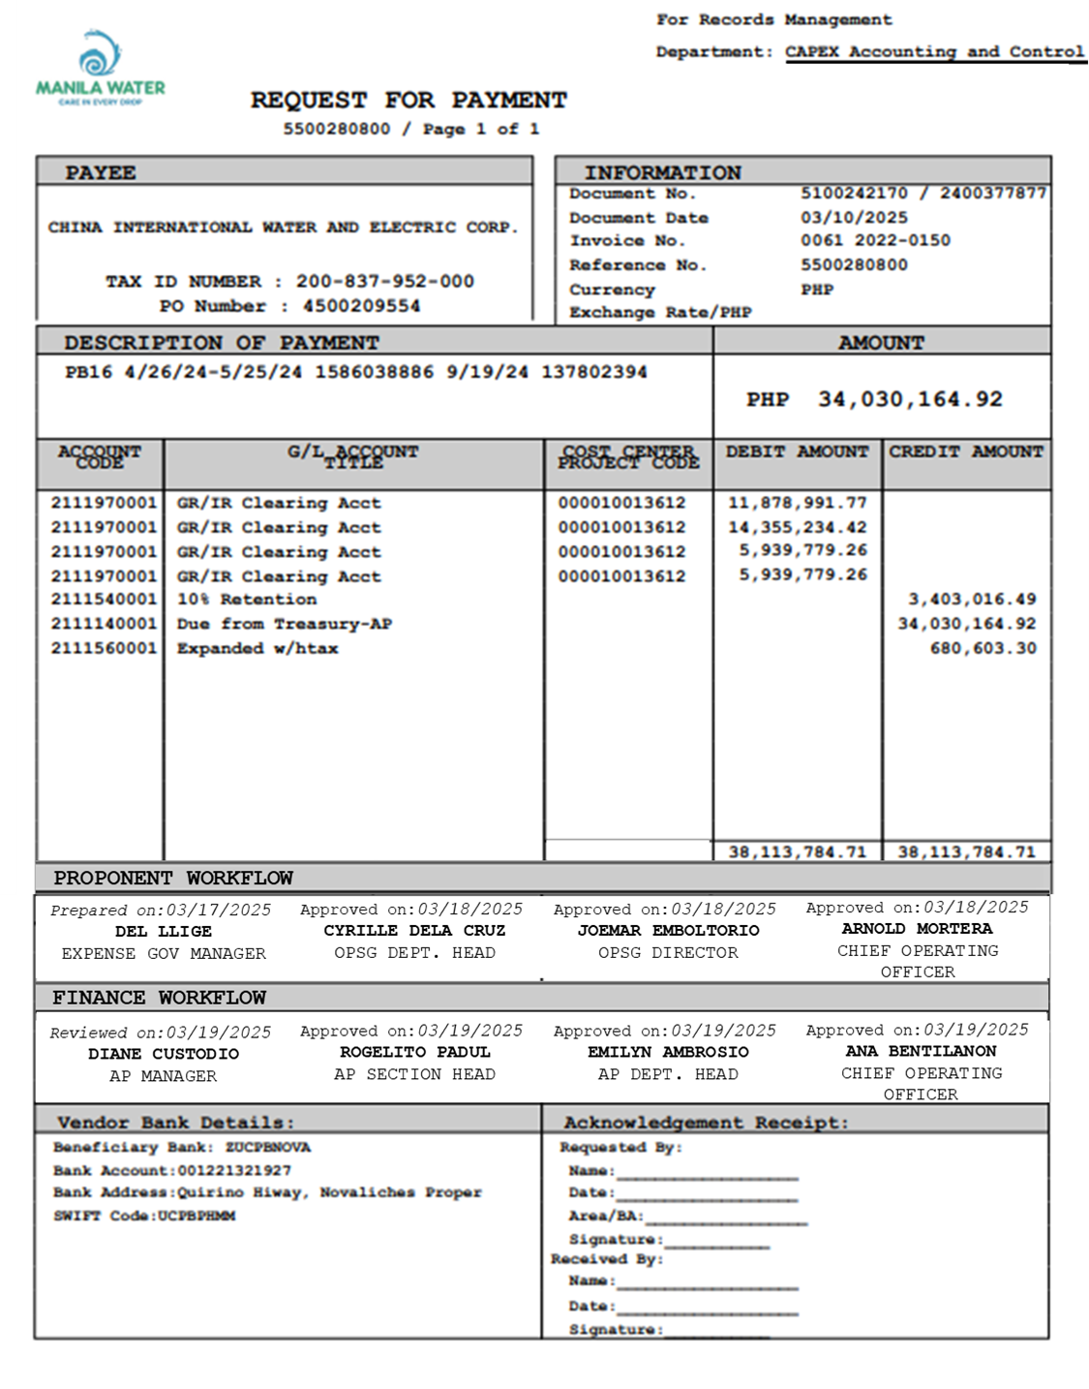

Printer Requirements

Legal Requirements

Form Fields

Sub Heading

Totaling

Sorting

Page Breaks

Stationery

Logo(s)

Bar Coding Requirements

Email Requirements

Existing Sample Forms

Assumptions in Functional Design
The following assumptions have been made in the functional design:
- The provided data structure, field mapping, and layout format are accurate and final as per the client's requirements.
- The logos provided for each company code are correct and approved for use.
- No additional sorting, page break, or special formatting requirements are expected unless specified later.
- The output will be generated in PDF format and integrated custom program for printing and preview.
- Any changes in business rules or additional requirements will be communicated and addressed separately

Open Issues in Functional Design
- Cost Type logic is still pending from MWC
- Workflow Development needs to be completed for RFP Form generation to work
- Technical team to identify the BAPI/FM to read the workflow details of the posted document from the development below:
S. No. | Reference Development
DID_S2P_024 | Flexible Workflow for PR_SES_RFP
DID_R2R_372 | Workflow for Financial Posting
BTP Downpayment Request Workflow | BTP Downpayment Request Workflow

Business Test Conditions

Scenario # | Input Selection Criteria | Expected Result
1 | PO Based Vendor Invoice posted via Workflow | Generate RFP Form with the expected information
2 | PO Based Vendor Credit/Debit Memo posted via Workflow | Generate RFP Form with the expected information
3 | PO Based Retention Invoice posted via Workflow | Generate RFP Form with the expected information
4 | PO Based Downpayment Recoupment Invoice posted via Workflow | Generate RFP Form with the expected information
5 | PO Based Retention and Downpayment Recoupment Invoice posted via Workflow | Generate RFP Form with the expected information
6 | Non-PO Based Vendor Transaction posted via Workflow | Generate RFP Form with the expected information
7 | Vendor Downpayment Request posted via Workflow | Generate RFP Form with the expected information

Related Documentation

Sample for RFP form with more 1 page:

